BL-CA11
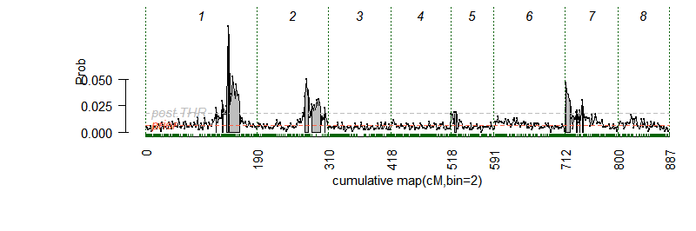 | 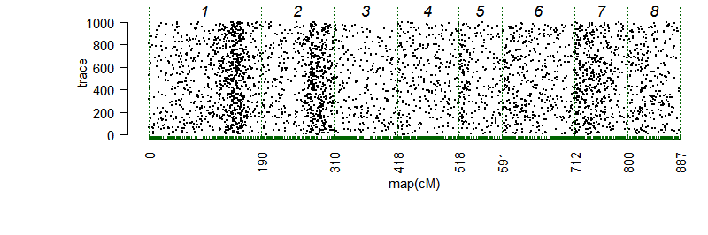
BL-CA12
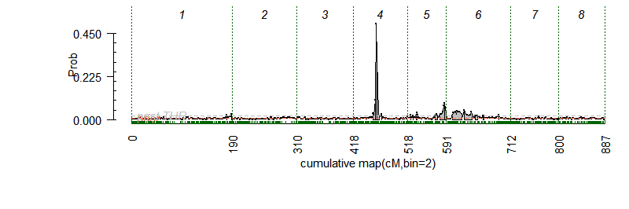 | 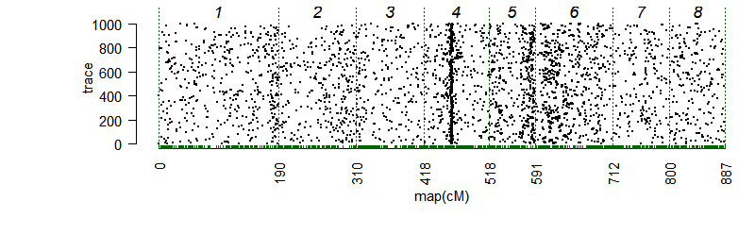
BL-TX12
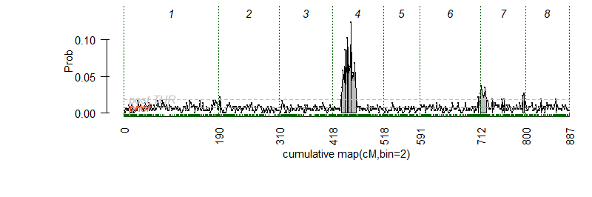 | 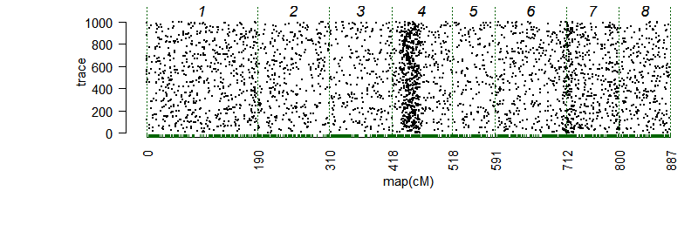
BL-TX13
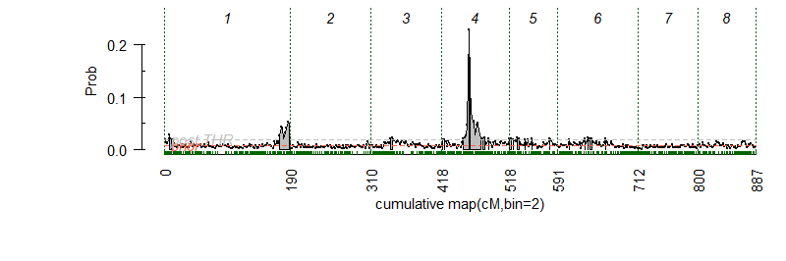 | 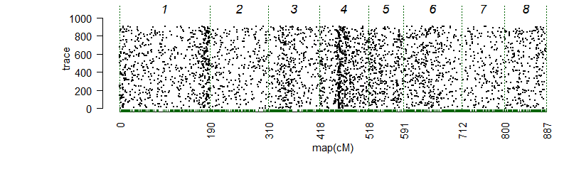
BL-mean
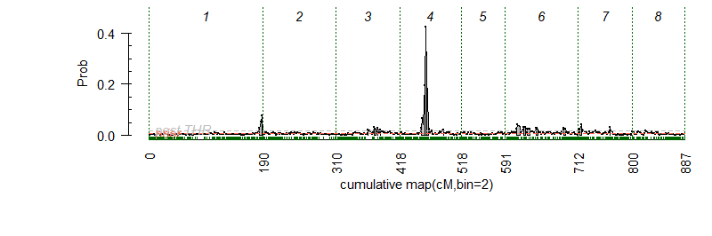 | 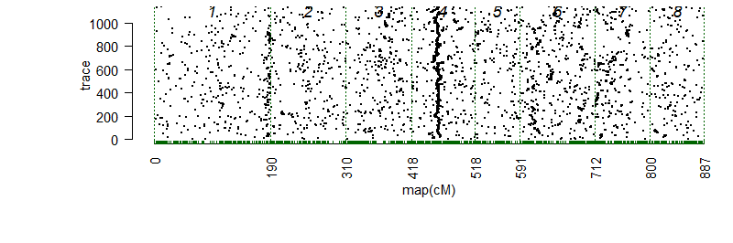
Fig. S1. Posterior positions (left) and trace samples QTL positions (right) based on an additive model performed using Visual FlexQTL software [1] for the blush (BL) from four environments (CA11, CA12, TX12, TX13), and the overall combined mean for 143 peach seedlings. CA11 = Fowler, California 2011, CA12 = Fowler, California 2012, TX12 = College Station, Texas 2012, TX13 = College Station, Texas 2013.

LG-4

ss_409901
ss_410134
ss_410165
ss_410336
ss_410398
ss_410478
ss_410794
ss_410955
ss_411147
ss_411188
ss_411196
ss_411601
ss_411637
ss_412338
0.0
0.1
0.2
0.3
qBL4-TX12
qBL4-TX13
qBL4-CA12
qBL4-mean

Fig. S2. Position of putative QTLs and peaks (large bold font) controlling the blush (BL) trait in peach at linkage group 4 (LG4) from four environments (CA11, CA12, TX12, TX13), and the overall mean generated using MapChart software [2].
CA11 = Fowler, California 2011, CA12 = Fowler, California 2012, TX12 = College Station, Texas 2012, TX13 = College Station, Texas 2013.

SSC-CA11
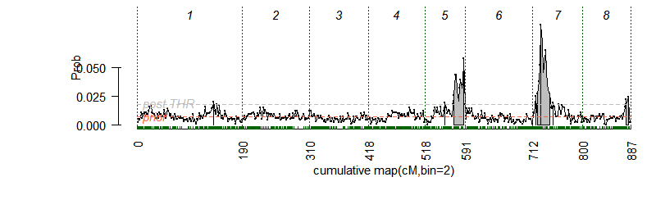 | 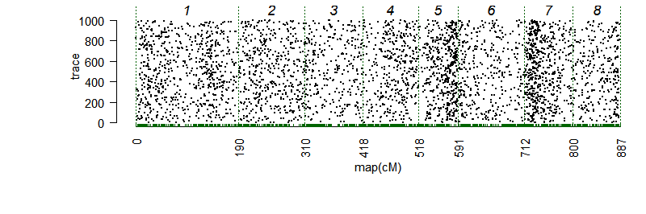
SSC-CA12
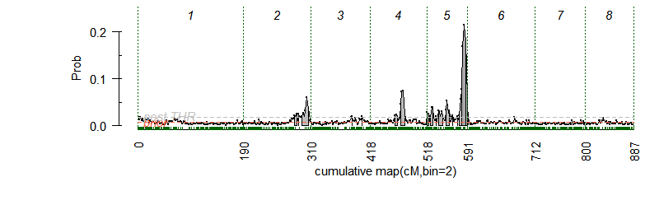 | 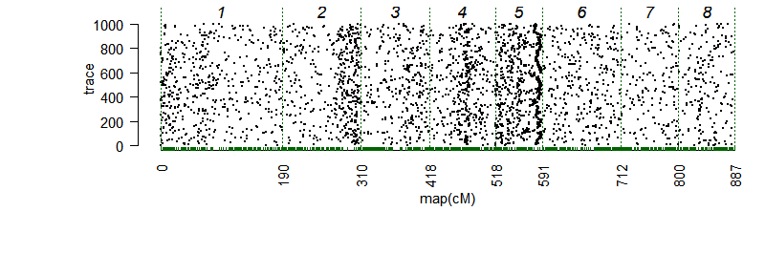
SSC-TX13
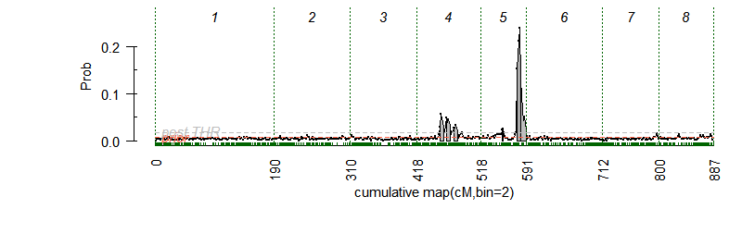 | 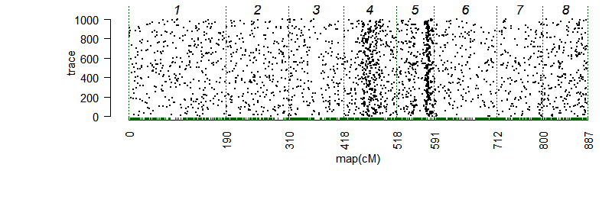
SSC-mean
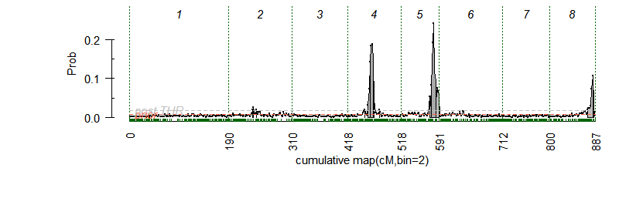 | 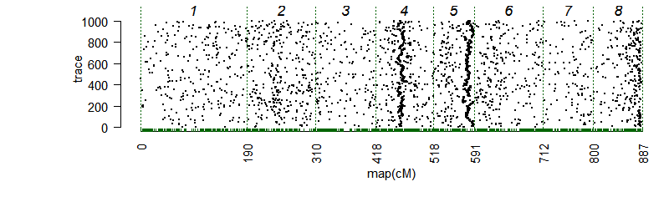
Fig. S3. Posterior positions (left) and Trace samples QTL positions (right) based on an additive model performed using Visual FlexQTL software [1] for the soluble solids concentration (SSC) from three environments (CA11, CA12, TX13), and the overall combined mean for 143 peach seedlings.
CA11 = Fowler, California 2011, CA12 = Fowler, California 2012, TX12 = College Station, Texas 2012, TX13 = College Station, Texas 2013.

TA-CA11
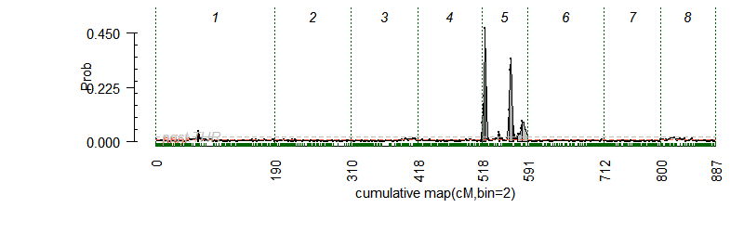 | 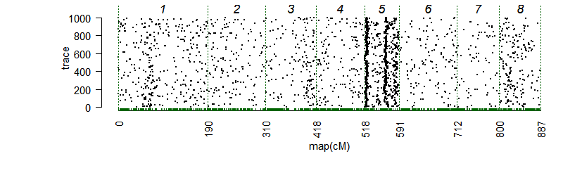
TA-CA12
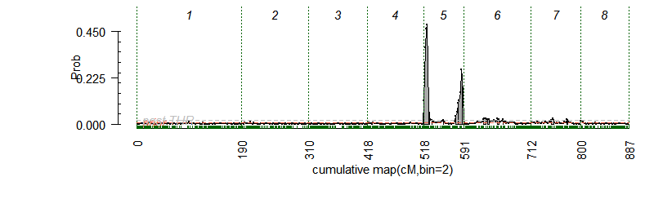 | 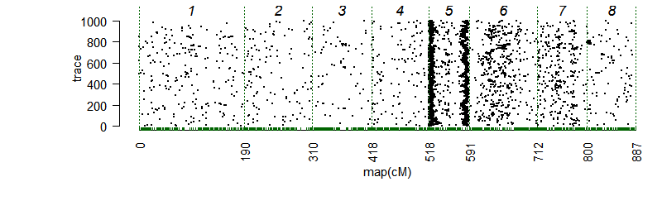
TA-TX12
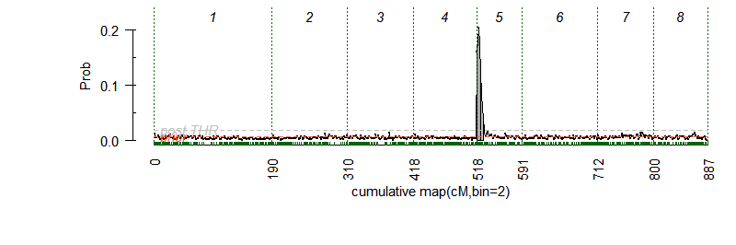 | 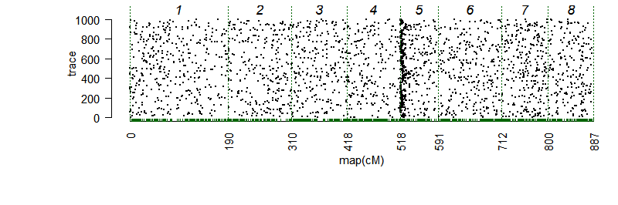
TA-mean
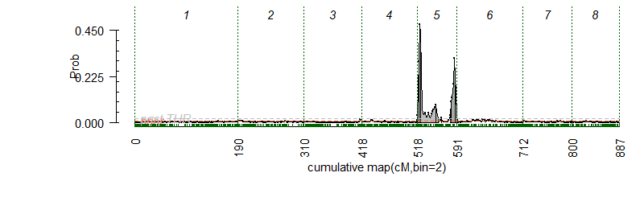 | 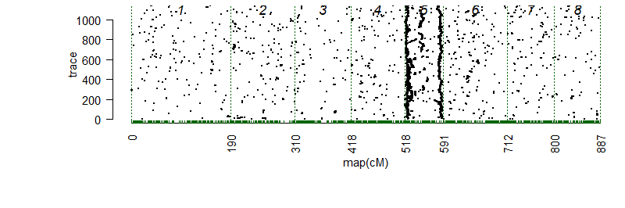
Fig. S4. Posterior positions (left) and trace samples QTL positions (right) based on an additive model performed using Visual FlexQTL software [1] for the titratable acidity (TA) from three environments (CA11, CA12, TX12), and the overall combined mean for 143 peach seedlings.
CA11 = Fowler, California 2011, CA12 = Fowler, California 2012, TX12 = College Station, Texas 2012, TX13 = College Station, Texas 2013.

Fig. S5. Correlation plot for titratable acidity (TA) content (%) among environments CA11 and CA12 in peach.
CA11 = Fowler, California 2011, CA12 = Fowler, California 2012.

r = -0.42**
Fig. S6. Correlation between fruit blush (BL) and ripening date (RD).
Blush = blush visually based on % coverage of red blush on skin using 0-5 scale (0 = 0% red coverage, 1 = 1%-20%, 2 = 21%-50%, 3 = 51%-80%, 4 = 81%-99%, 5 = 100%).
Ripening date in Julian days
** Pearson correlation is significant at the 0.01 level (2-tailed).

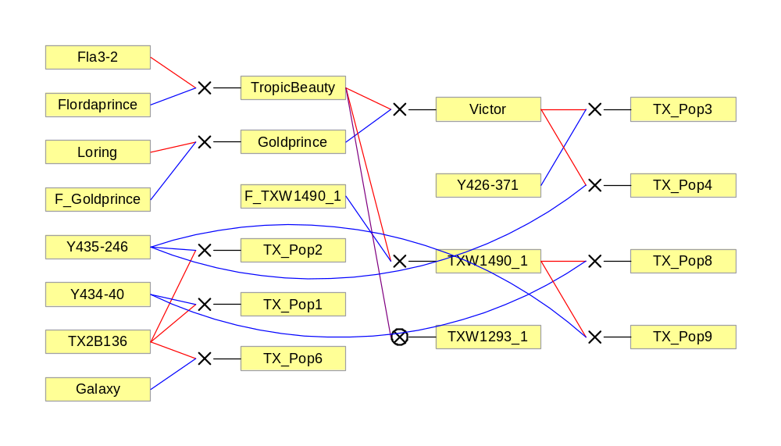
(n =36)
(n =19)
(n =27)
(n =22)
(n =8)
(n =16)
(n =15)
Fig. S7. Pedigree of the seven peach families and their progeny number. Red and blue lines link progeny to female and male parents, respectively.

References
1. Bink MCAM, Boer MP, ter Braak CJF, Jansen J, Voorrips RE, van de Weg WE. Bayesian analysis of complex traits in pedigreed plant populations. Euphytica. 2008;161(1-2):85-96.
2. Voorrips RE. MapChart: Software for the Graphical Presentation of Linkage Maps and QTLs. J Hered. 2002;93(1):77-78.

